Meeting log for Team: Singh-Bhawandeep Sp26-1
- Team Meeting with Advisor [1-28-26]
Absent: none
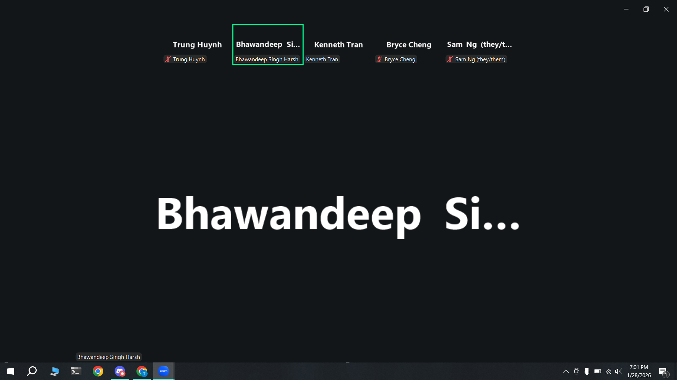
- We can pick either Janitorial Robot or Self balancing inverting pendulum robot (Integrated with Zybo and reinforcement learning).
- We can discuss with Dan Harkey to get his opinion on which idea would be more aligned with CMPE 295A/B.
- Professor Harsh stated that implementing the pendulum with a Zybo is complex, but to add reinforcement learning to find the parameters of the pendulum instead of manually calculating it with Matlab.
- The goal for this semester is to have Requirements, Architecture, and Design documents completed.
- A minimal prototype can be produced, but is not needed. The main goal is to have our requirements, architecture, and design documents frozen, so in CMPE 295B can be purely focused on execution and coding.
- Professor Harsh recommended the first month to be a literature review of our project to get knowledge on what the current state of the art is and to start thinking about the project scope.
- Have a google drive that he has access to, so he can be up to date with our progress such as data/requirements/architecture/design documents.
- Team Meeting [2-2-26]
Absent: none
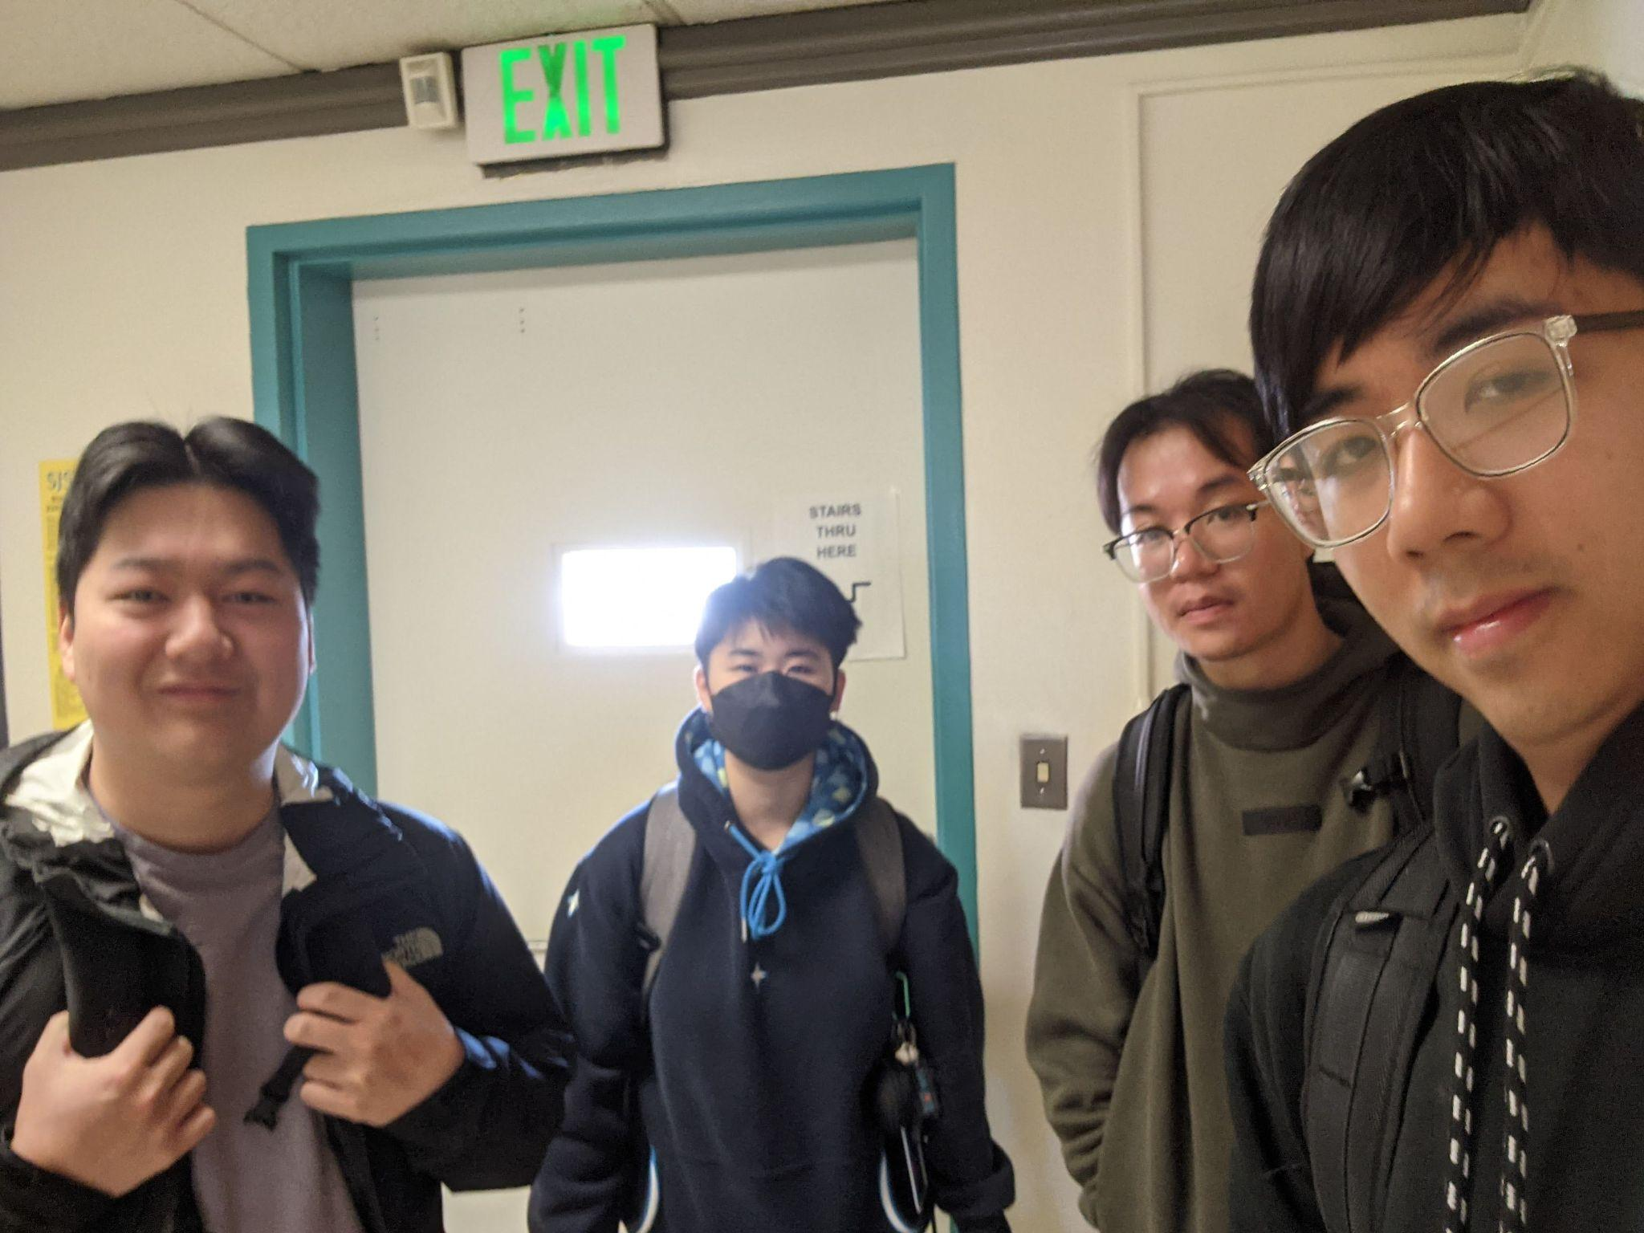
- We began finalizing our project topic and delegated who would be working on the abstract and presentation.
- Team Meeting with Advisor [2-11-26]
- Planned topics: ask whether we need a PCB design for our project and the complexity of using a tracker to provide following
- using HC-SR04 ultrasonic sensor for obstacle detection
- ask whether he wants to be sent whatever we’re working on, he replies and we ask him for more detail during the meeting

